1. 
2. Let’s add the following template to Intellij.  
   A blue rectangle with red text

   Description automatically generated with low confidence  
     
   A screenshot of a computer

   Description automatically generated with medium confidence  
     
   
3. A screen shot of a computer

   Description automatically generated with medium confidence
4. 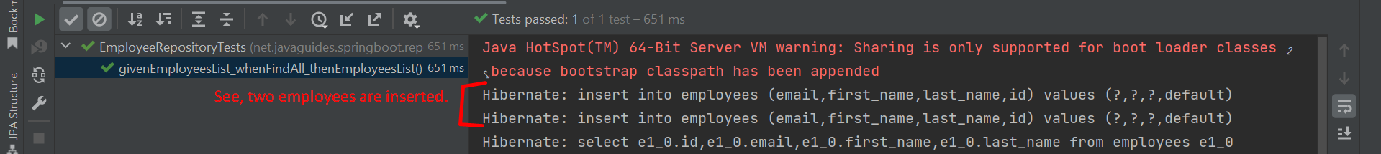
5. 